Chapter 1 Overview

1. Types of markets

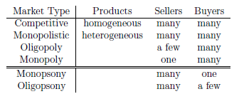

1. CPI = total spending on a market basket of goods
2. Inflation rate = CPI(current year) / CPI(base year)
3. Real price = Nominal price(current year)/inflation rate(base year to current year)
4. Positive analysis: the relationship of cause and effect (explanation, prediction).

Normative analysis: analysis on what ought to be (value judgements)

Chapter 2 Supply and Demand

1. Demand and supply curves: usually price on y-axis, quantity on x-axis.
2. Change in price causes movement along the supply/demand curve; change in something other than price (e.g., production cost, income) causes shift of supply/demand curve.
3. Substitutes: increase in price of A leads to increase in demand of B. (chicken and pork)

Complements: increase in price of A leads to decrease in demand of B. (pasta and pasta sauce)

1. Surplus and shortage.

Chapter 3 Elasticities of Demand

1. Price elasticity of demand:
$$E_{P}^{D}=\frac{\frac{ΔQ}{Q}}{\frac{ΔP}{P}}=\frac{dQ}{dP}⋅\frac{P}{Q}$$

2. Properties of price elasticity of demand
   1. Usually negative: when price increase, demand decreases
   2. When $\left|E_{P}\right|>1$, the good is price elastic; when $\left|E_{P}\right|<1$, the good is price inelastic.
   3. When $\left|E_{P}\right|=1$, the total consumer expenditure= $P⋅Q_{D}(P)$ is maximized.
3. Income elasticity of demand

$$E_{I}=\frac{dQ}{dI}⋅\frac{I}{Q}$$

It is usually positive.

1. Cross price elasticity: measures the %change in quantity demand of $x$ resulting from %change in price of $y$
 $$E_{QxPy}=\frac{\frac{dQ_{x}}{Q_{x}}}{\frac{dP_{y}}{P_{y}}}=\frac{dQ_{x}}{dP_{y}}⋅\frac{P_{y}}{Q_{x}}$$

  1. If y is a substitute of x, the cross price elasticity is positive
   2. If y is a complement of x, the cross price elasticity is negative
2. Elasticity over short run versus long run
   1. Consumption goods: in the short run, people have to buy them for daily life; but in the long run, people may change habits in face of high price. Therefore, consumption goods are more elastic in the long run.
   2. Durable goods: consider cars. In the short run, if price of cars increases, people might use current car longer; but in the long run, people have to replace their cars. So durable cars are more elastic in the short run.

Lecture 4 Price Elasticity of Supply; Consumer Preferences

1. Price elasticity of supply:

$$E_{P}^{S}=\frac{dQ_{S}}{dP}⋅\frac{P}{Q_{s}}$$

Supply is more elastic in the long run, because when price increases, firms have to hire workers and buy machines, and cannot start increase production immediately.

1. Assumption for preferences:
   1. Completeness: can always rank any basket of goods
   2. Transitivity: $A≻B$ and $B≻C$ implies $A≻C$
   3. Non-satiation: more is better
   4. Convexity: given two different points A, B ($u(A)=u(B)$), we have $u\left(\frac{A+B}{2}\right)≥u\left(A\right)=u(B)$.
2. Properties of indifference curves:
   1. Download sloping: from the non-satiation assumption
   2. Two indifference curves cannot cross: from non-satiation and transitivity
   3. Shape: convex
3. Marginal rate of substitution (MRS): how many units of $Y$ one is willing to give up to get one more unit of $X$.
$$MRS=-\frac{dy}{dx}$$

4. Perfect substitution: MRS is constant. One unit of X always substitutes constant units of Y.

Perfect complements: Indifference curves are shaped as right angles (e.g., left and right shoes).

Lecture 5-6 Utility, MRS, Optimization with Budget Constraint

1. Examples of utility function:
   1. Perfect substitutes: $U\left(x,y\right)=ax+by$
   2. Perfect complements: $U\left(x,y\right)=\min\left(ax,by\right)$
   3. Cobb-Douglas function: $U\left(x,y\right)=Ax^{b}y^{c}$
2. Derivation of MRS from utility function:

$$u=U\left(x,y\right)=C⟹\frac{∂u}{∂x}+\frac{∂u}{∂y}⋅\frac{dy}{dx}=0⟹-\frac{dy}{dx}=\frac{\frac{∂u}{∂x}}{\frac{∂u}{∂y}}$$

Thus

$$MRS=\frac{\frac{∂u}{∂x}}{\frac{∂u}{∂y}}$$

1. Optimize utility subject to budget constraint
 $$\max{U\left(x,y\right)}$$

 $$subject to xP_{x}+yP_{y}=I$$

 $$x≥0, y≥0$$

1. Interior solution ($x>0 and y>0$): Lagrange multiplier. $\frac{P_{x}}{P_{y}}=\frac{U_{x}}{U_{y}}$ must have a solution for $x>0 and y>0$.
   2. Corner solution ($x=0$ or $y=0)$: $\frac{P_{x}}{P_{y}}=\frac{U_{x}}{U_{y}}$ has no solution for $x>0 and y>0$. If $MRS=\frac{U_{x}}{U_{y}}>\frac{P_{x}}{P_{y}}$, then we do not want to consume y, and the solution is at $y=0$; If $MRS=\frac{U_{x}}{U_{y}}<\frac{P_{x}}{P_{y}}$, then we do not want to consume x, and the solution is at $x=0$.
2. Normal good: quantity demanded increases with income.

Inferior good: quantity demanded decrease with income.

Lecture 7 Substitution and Income Effect, Market Demand, Consumer Surplus

1. Substitution effect and income effect: when the price of a good changes, the change in quantity demanded can be divided into two parts:
   1. Substitution effect: As the relative price changes, people will increase the demand for the good that becomes relatively cheaper (vice versa), while keep the utility level constant.
   2. Income effect: As the price changes, the purchasing power changes, people will be able to consume a different amount of goods, while keep the relative price constant.

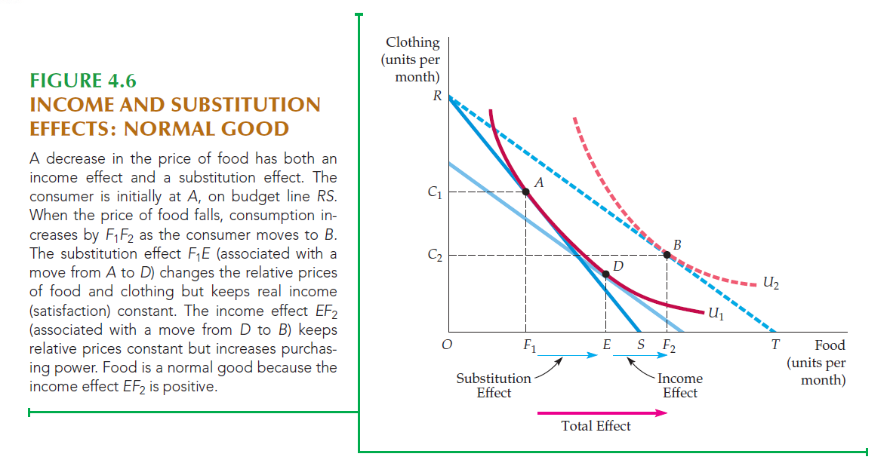

1. Direction of substitution effect and income effect:
   1. Under the convex indifference curve assumption, substitution effect will always lead to an increase in the quantity demanded with a decline in price.
   2. The direction of income effect can be in either way.
2. When price decreases:
   1. Normal good: both substitution effect and income effect increase its quantity
   2. Inferior good: substitution effect increases quantity, but income effect decreases quantity
   3. Giffen good: a special case of inferior good. The magnitude of income effect is larger than substitution effect, and thus it has an upward demand curve.
3. Market demand = sum of demand for all individuals
4. Consumer surplus = total willingness to pay – total expenditure

Lecture 9 Risk Preference, Risk Premium

1. Risk averse: given the same expected payoff, prefer the less risky one. Diminishing marginal utility of income. $u\left(E\left(x\right)\right)>E\left(u\left(x\right)\right)$, e.g., $u\left(x\right)=ln⁡(x)$.

Risk neutral: given the same expected payoff, indifferent about risk. Linear marginal utility of income. $u\left(E\left(x\right)\right)=E\left(u\left(x\right)\right)$, e.g., $u\left(x\right)=x$.

Risk seeking: given the same expected payoff, prefer the riskier one. Increasing marginal utility of income. $u\left(E\left(x\right)\right)<E\left(u\left(x\right)\right)$, e.g., $u\left(x\right)=x^{2}$.

1. For a risk-averse person, the maximum amount of (expected value of) money he would pay to avoid taking a risk is called risk premium.

Lecture 10 Insurance, Production Function

1. Insurance premium: if the insurance premium is equal to the expected loss, then a risk-averse person will buy the insurance, since the insurance can make the risk smaller. Therefore, insurance company can charge an insurance premium that is higher than the expected loss.

On the other hand, the insurance company can diversify the risk when the number of insurance buyers is large.

1. Production function: $q=F(k,L)$, where $q$ is output, $k$ is capital, $L$ is labor.
2. It’s easier to change labor level but not to change capital in a short time.

Lecture 11 Production Functions

1. In the short run, $K$ is constant, so $q$ is function of $L$ only.
   1. Average product of labor: $AP_{L}=\frac{q}{L}$
   2. Marginal product of labor: $MP_{L}=\frac{∂q}{∂L}$
   3. When $MP=0$, $q$ is maximized.
   4. When $MP=AP$, $AP$ is maximized.
2. In the long run, both $K$ and $L$ are variables.
   1. Isoquants: curves showing all possible combinations of $K$ and $L$ that yield the same $q$.
   2. Marginal rate of technical substitutions: $MRTS=-\frac{dK}{dL}$

$MRTS=\frac{MP_{L}}{MP_{K}}$

Lecture 12 Production Functions and Cost of Production

1. Increasing return to scale: $Q\left(2K,2L\right)>2Q(K,L)$. One big firm is more efficient than many small firms.

Constant return to scale: $Q\left(2K,2L\right)=2Q(K,L)$. One big firm is as efficient as many small firms.

Decreasing return to scale: $Q\left(2K,2L\right)=2Q(K,L)$. One big firm is as efficient as many small firms.

1. Cobb-Douglas: $Q\left(K,L\right)=AL^{α}K^{β}$
   1. If $α+β>1$, increasing return to scale
   2. If $α+β=1$, constant return to scale
   3. If $α+β<1$, decreasing return to scale
2. Accounting cost: actual expenses + depreciation

Economic cost: opportunity cost, the most valuable forgone alternative

Lecture 13 Cost Functions

1. Production cost can be decomposed in two ways:
   1. Labor and capital: $C=w⋅L+r⋅K$
   2. Fixed and variable cost: $C\left(q\right)=FC+VC\left(q\right)$
2. Short run cost function: in the short run, capital is constant.
   1. Average total cost $ATC=\frac{TC}{q}$
   2. Average variable cost $AVC=\frac{VC}{q}$
   3. Marginal cost $MC=\frac{dTC}{dq}=\frac{dVC}{dq}$
   4. When $MC=AVC$, $AVC$ is minimized.

When $MC=ATC$, $ATC$ is minimized.

It means $MC$ intersects with $AVC/ATC$ at their minimum level.

1. Long run cost function: in the long run, both $K$ and $L$ are variable. To find the optimal allocation of K and L given a fixed cost, we need to find the tangent point of cost equation and production function:

Cost: $C=w⋅L+r⋅K$, slope is $-\frac{w}{r}$

Production: slope is $-MRTS=-\frac{MP_{L}}{MP_{K}}$

So $\frac{MP_{L}}{MP_{K}}=\frac{w}{r}$ solves the optimal allocation of $K$ and $L$.

1. As cost changes, the optimal $K$ and $L$ also change, and the relationship of optimal $K$ and $L$ is called “expansion path”.

Lecture 14 Cost of Production and Profit Maximization

1. Long run cost $≤$ short run cost, because short run is a “constrained” optimization version of long run.
2. Economies of scope: if the firm produces two types of products that are closely linked, the cost is lower than if producing separately.

$$SC=\frac{C\left(q_{1}\right)+C\left(q_{2}\right)-C(q_{1},q_{2})}{C(q_{1},q_{2})}$$

If $SC>0$, it’s economies of scope; if $SC<0$, it’s diseconomies of scope.

Lecture 15 Short Run and Long Run Supply

1. In a perfect competition market, profit $π\left(q\right)=P⋅q-C(q)$, where $P$ is price, and $C(q)$ is cost. Profit maximization $π^{'}\left(q\right)=0$ leads to $P=MC(q)$.
2. $MC\left(q\right)=P$ is the condition that maximizes profit. However, the maximized profit may still be lower than 0, or even lower than shut down.

If the firm decides to produce, it will produce at $MC\left(q\right)=P$; otherwise it will shut down.

* 1. When , the firm makes profit; when $P<ATC$, the firm has loss.
  2. When $P>AVC$, the firm still produces; when $P<AVC$, the firm shuts down.

Note: when $AVC<P<ATC$, the firm produces but has loss.

1. Producer Surplus = Revenue – Total Variable Cost

Lecture 16 Long Run Supply and Analysis of Competitive Markets

1. Long run competitive equilibrium: In the short run, when market price P is high, the firms will produce until $SMC=P$, and $P=SMC>SAC$, where $SMC$ is short run marginal cost, $SAC$ is short run average total cost. The existing firms are making profits, so old firms expand and new firms enter, which lead to price decreasing. The price will decrease until $P=LMC=LAC$, so that firms have no economic profit.
2. In a constant-cost Industry, the prices of some or all inputs to production does not change as the industry expands and the demand for the inputs grows.

In an increasing-cost industry, the prices of some or all inputs to production increase as the industry expands and the demand for the inputs grows.

In a decreasing-cost industry, the prices of some or all inputs to production increase as the industry expands and the demand for the inputs grows.

1. The primary reason for the constant cost is that industry demand for the accompanying raw materials is much lower than the overall demand for these raw materials.

The fundamental reason for the increased cost in increasing cost industry is that industry demand for raw materials accounts for a substantial portion of overall raw materials demand.

1. Long run market supply with constant cost: if price is higher than the minimum $LAC$, then existing firms are earning positive economic profit, and new firms will keep entering. Thus supply will increase and thus it drives the price down, until price is back to the minimum $LAC$ again. Therefore, long run supply is a horizontal line at the price of minimum LAC.

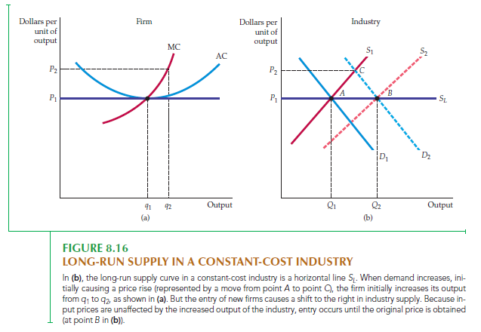

1. Long run market supply with increasing cost: if price is higher than the minimum $LAC$, then existing firms are earning positive economic profit, and new firms will keep entering. Then $MC$ and $AC$ will increase, and the minimum $LAC$ will be higher. The supply will increase, and market price will move to the new minimum LAC. Therefore, the new equilibrium will have a higher price and higher quantity. So the supply curve is upward sloping.

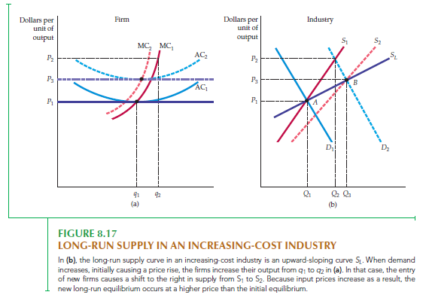

1. Long run market supply with decreasing cost: similarly, the supply curve is downward sloping.
2. Consumer/Producer surplus impacted by price ceiling/floor

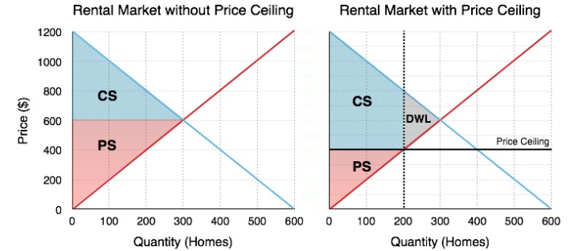

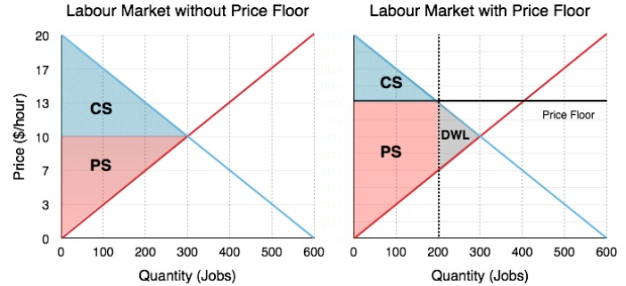

1. Deadweight loss

Lecture 17 Supply Restrictions, Tax, and Subsidy

1. (Agriculture) price support: the government sets a price higher than the market equilibrium price, and buys excess supply. Consumers loss, producers gain, and government pays a cost. The total change in welfare is

$$ΔCS+ΔPS-Cost to Govt.=D-\left(Q_{2}-Q_{1}\right)P_{S}$$

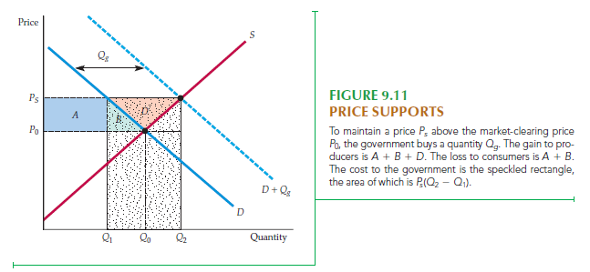

1. Supply restriction: if the government restricts the quantity supplied to be $Q_{1}$, then

$$ΔCS=-\left(A+B\right), ΔPS=A-C$$

$$DWL=-(B+C)$$

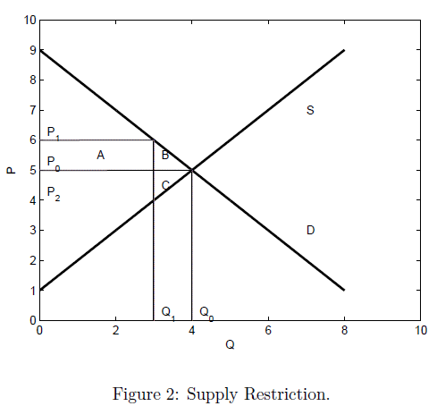

1. Zero quota (on import): world price $P_{W}$ is lower than the domestic price $P_{D}$. In a free market, the price is $P_{W}$, and total quantity consumed is $Q_{D}$, of which $Q_{S}$ is supplied domestically and rest imported. If no import is allowed, the price is $P_{D}$ and quantity is $Q_{0}$. The impact of import restriction (compared to free market) is:

$$ΔCS=-\left(A+B+C\right), ΔPS=A$$

$$DWL=-(B+C)$$

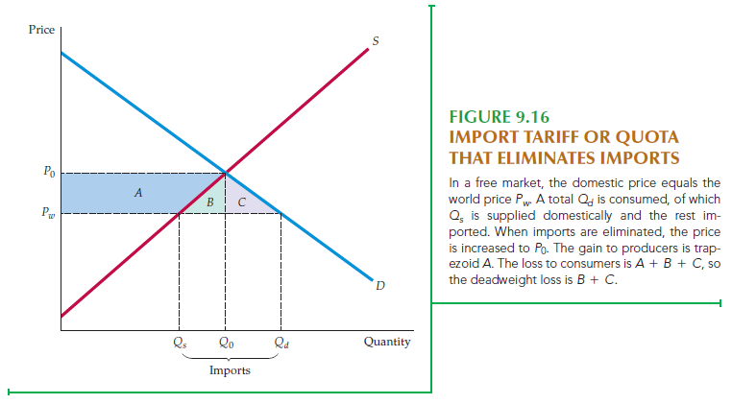

1. Non-zero quota (on import): if the government sets a non-zero quota $k$, then the domestic price is $P^{*}$ where the difference between domestic demand and domestic supply equals $k$. Then:

$$ΔCS=-\left(A+B+C+D\right), Δ{PS}_{D}=A$$

$$net domestic loss=-(B+C+D)$$

The foreign producer surplus increases by $Δ{PS}_{F}=D$

$$DWL=-(B+C)$$

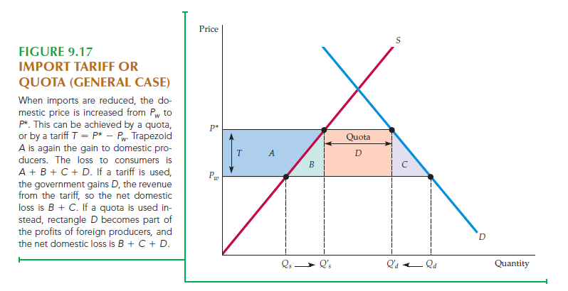

1. Import tariff: similar to non-zero quota, but the restriction is not set by quota, but charging a tariff of $P^{*}-P_{W}$.

$$ΔCS=-\left(A+B+C+D\right), Δ{PS}_{D}=A$$

The government has profit of $ΔG=D$ (where in non-zero quota, this is the surplus of foreign producers.)

$$DWL=Domestic Loss=-(B+C)$$

Lecture 18 Tax, Subsidy and General Equilibrium

1. The quantity after tax is where the price paid by consumers and received by producers differ by the tax amount.

$$ΔCS=-\left(A+B\right), ΔPS=-\left(C+D\right), ΔG=A+D$$

$$DWL=-(B+C)$$

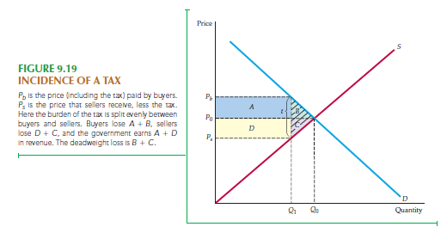

1. Whether the tax is imposed on consumer or producer does not make a difference in the final price paid by consumers/received by producers.

The relative amount borne by consumers and producers depends on relative elasticities of demand and supply, not on whom the government imposes tax.

The party with inelastic quantity bears more relative amount of tax.

1. Subsidy is the “opposite” of tax, sellers receive more than buyers pay.

$$ΔCS=A+B, ΔPS=C+D, ΔG=-\left(A+B+C+D+E\right)$$

$$DWL=-E$$

The benefit of subsidy goes more to the more inelastic party.

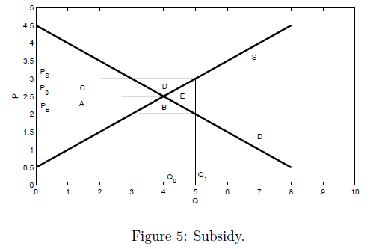

1. So far, our analysis is mainly partial equilibrium, i.e., ignore effect from other markets like substitutions and complements.

In contrast, general equilibrium considers feedback effect of other markets, i.e., the price/quantity adjustment caused by other related markets.

1. Edgeworth box. Interpretation: A has 7 foods and 1 cloth (read from $O_{A}$ in lower left corner); B has 3 foods and 5 clothes (read from $O_{B}$ from upper right corner).

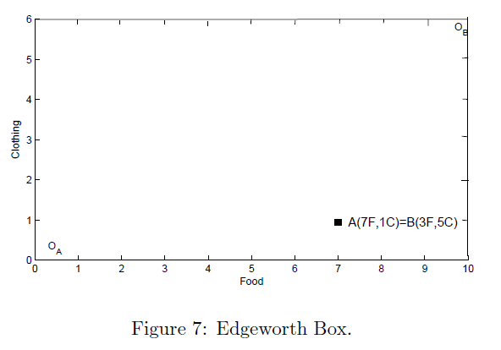

Lecture 19 Efficiency in Exchange, Equity and Efficiency, and Efficiency in Production

1. Suppose the initial state is A, where the indifference curve of $U_{J}^{1}$ and $U_{K}^{1}$ intersects. Then all points in the shaded area between $U_{J}^{1}$ and $U_{K}^{1}$ will make both persons better off.

At points $C$ and $D$, the MRS of both people are identical (since the indifference curves are tangent). Both $C$ and $D$ are an efficient allocation.

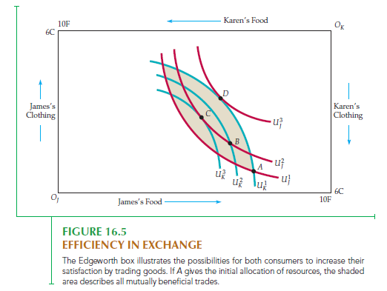

1. Contract curve: all possible efficient allocations of food and clothing, i.e., all points of tangency between James’s and Karen’s indifference curves.

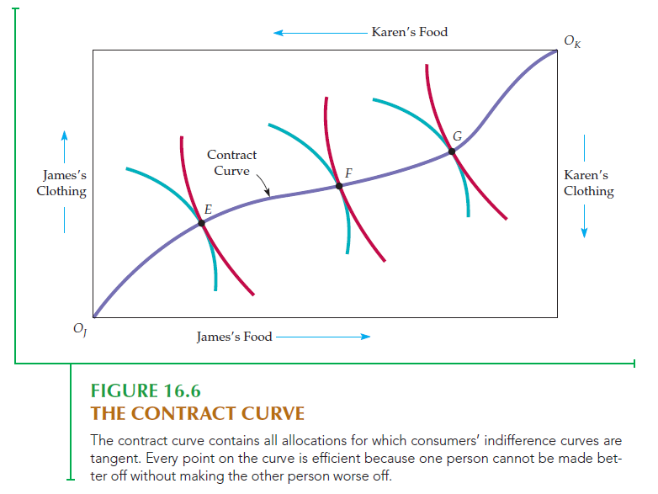

1. General equilibrium in a competitive market: suppose there are 2 consumers A and B, and 2 goods X and Y in the market. Each consumer has an initial amount of X and Y respectively, and each consumer has a utility function. Assume the total amount of X and Y in the market equals the sum of initial amount held by A and B.

The equilibrium state has 5 unknowns: $(x_{A},y_{A},x_{B},y_{B},p)$, with 6 equations (here $p$ is the relatively price of Y when we assume price of X is 1):

* Utility maximization for A and B: $\frac{UA_{X}}{UA_{Y}}=\frac{1}{p}$, $\frac{UB_{X}}{UB_{Y}}=\frac{1}{p}$
* Total amount of goods: $x_{A}+x_{B}=total X$, $y_{A}+y_{B}=total Y$
* Budget: $x_{A}+py_{A}=initial budget of A$, $x_{B}+py_{B}=initial budget of B$

Here one of the equations is redundant, and thus we can solve the general equilibrium.

1. Utility possibilities frontier: the utility levels when two individuals have reached the contract curve.
2. Production in Edgeworth box: the x and y axis are labor and capital, and indifference curve is the output.

Lecture 20 Production Possibility Frontier and Output Market Efficiency

1. Marginal rate of transformation (MRT) of food for clothing: how much clothing must be given up to produce one more unit of food.
2. $MRT=\frac{MC_{F}}{MC_{C}}$, where $MC_{F}$ is the marginal cost of producing food, and $MC_{C}$ is the marginal cost of producing clothing.
3. The production possibilities frontier shows the various combinations of food and clothing that can be produced with fixed inputs of labor and capital, holding technology constant.
4. Output market efficiency: a Pareto efficient result occurs when production possibilities frontier is tangent to indifference curve, i.e.,

$$MRT=MRS$$

The reason is: (1) $MRT=\frac{MC_{F}}{MC_{C}}$ (2) by profit maximization, $MC_{F}=P_{F}, MC_{C}=P_{C}$; (3) consumers maximize utility: $MRS=\frac{P_{F}}{P_{C}}$

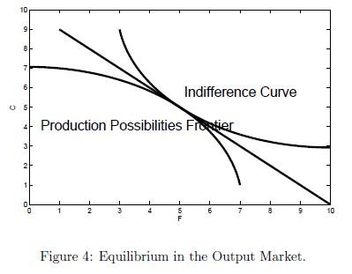

Lecture 21 Why Markets Fail

1. Market power: e.g., monopoly power
2. Incomplete information
3. Externalities: Consumption or production has indirect effect on other consumption or production, which is not reflected in market prices. E.g., pollution.
4. Public goods: e.g., no patent protection.

Lecture 22 Monopoly

1. In perfect competition, long run market price is the lowest average total cost, and firms are price takers.
$$R=PQ, AR=MR=P$$

2. In contrast, monopolist only takes market demand curve, but its supply can affect the market price.
$$R=P\left(Q\right)Q, AR=P\left(Q\right), MR=\frac{dR}{dQ}=P\left(Q\right)+Q\frac{dP}{dQ}<P(Q)$$

3. Profit maximization in monopoly: $MR=MC$ still applies. The difference between competitive market and monopoly is: (1) in competitive market, $MR=MC$ gives not only the quantity produced, but also the firm have to take price $P=MC=MR.$ (2) in monopoly, $MR=MC$ only gives the quantity produced. The price $P$ is determined by the market demand curve, and $P>MR=MC.$

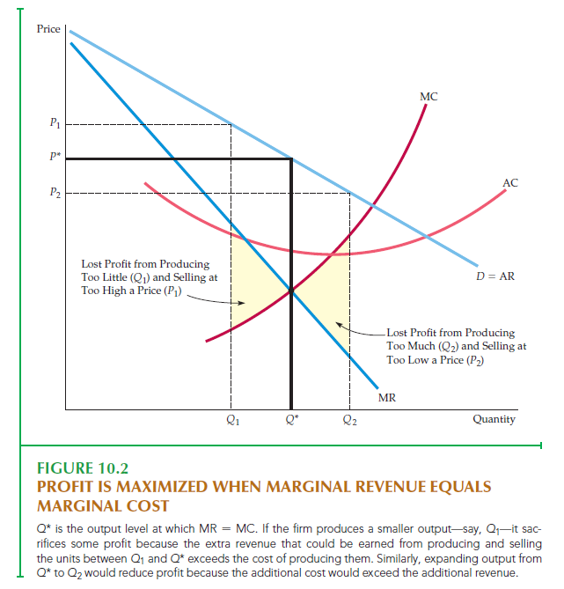

1. In monopoly, average revenue (AR) is the same as the market demand curve.
2. Lerner’s index: $L=\frac{P-MC}{P}$ measures the monopoly power of a firm.
   1. In a competitive market, Lerner’s index = 0
   2. In a monopolistic market, Lerner’s index > 0
   3. $L=\frac{1}{\left|E_{D}\right|}$. Lerner’s index is the inverse of the demand elasticity. Proof: $MR=P+Q\frac{dP}{dQ}=P+P\left(\frac{Q}{P}\frac{dP}{dQ}\right)=P+P\frac{1}{E_{D}}, MR=MC$ so $\frac{1}{|E_{D}|}=\frac{P-MC}{P}$